Original Article
Molecular Characterization of a Human Genomic Amplicon with BGN- and G6PD-Annotated Reference Matches
Abstract
Background: Targeted amplicon assignment can be difficult when one consensus sequence retrieves highly similar records with different gene annotations. We characterized an approximately 700-bp human genomic amplicon from 13 blood samples and evaluated BLASTn similarity and phylogenetic placement relative to BGN- and G6PD-annotated human references.
Methods: Genomic DNA was extracted, amplified with primer pair 4_144_F/4_833_R, assessed by agarose gel electrophoresis, and sequenced bidirectionally by Sanger sequencing. Forward and reverse reads were assembled into consensus sequences, followed by BLASTn (megablast), ClustalW multiple sequence alignment in MEGA, and Neighbor-Joining analysis using the Tamura-Nei model with bootstrap evaluation.
Results: All 13 samples produced a single visible PCR band at the expected size and successful bidirectional sequencing. BLASTn top-hit sets recurrently contained both BGN-annotated and G6PD-annotated records, with 99-100% query coverage, 99.64-100% identity, and E-values of 0. Multiple sequence alignment showed high conservation. In most individual sample-reference trees, study sequences were positioned within or adjacent to BGN-annotated branches, whereas G6PD-annotated references frequently formed a separate supported cluster. The all-sample tree showed bootstrap values of 43-98.
Conclusion: The data support reliable sequencing of a single targeted human genomic amplicon and high similarity to records annotated as BGN and G6PD. Because one primer pair and one amplicon generated both annotation groups, the findings do not independently confirm two gene targets. Definitive locus assignment requires reference-genome mapping or independent target-specific validation.
Keywords: Sanger Sequencing; BLAST; BGN; G6PD; Phylogeny
Introduction
Targeted Sanger sequencing remains useful for validating defined genomic regions when direct base-level sequence information is required. Its value depends not only on obtaining a clean amplicon and high-quality bidirectional reads, but also on interpreting the resulting consensus sequence in a way that is consistent with the assay design and the reference data used for comparison (1-7).
BGN encodes biglycan, a small leucine-rich proteoglycan involved in extracellular matrix organization, tissue remodeling, inflammation, and cell signaling (8-11). G6PD encodes glucose-6-phosphate dehydrogenase, a key enzyme in the pentose phosphate pathway that protects cells against oxidative stress; clinically relevant G6PD variation is associated with reduced enzyme activity and hemolytic risk (12-16). Although both genes are biologically important, similarity to records carrying these annotation labels does not by itself demonstrate that two independent gene targets were amplified.
BLASTn is widely used to identify nucleotide sequences by comparing a query with public database records (17,26). However, sequence-database records can contain annotation inconsistencies or may represent genomic regions whose descriptive labels are not sufficient for locus-level assignment, so top-hit descriptions should be interpreted together with alignment context and assay-specific information (18). Multiple sequence alignment and phylogenetic reconstruction can provide additional context by showing conservation and relative placement among study and reference sequences, but these analyses do not replace target-specific locus verification (19-25).
The present study therefore characterized a single approximately 700-bp amplicon generated from 13 human blood-derived genomic DNA samples. The objective was to document PCR and Sanger sequencing performance, describe the recurrent BGN- and G6PD-annotated records retrieved by BLASTn, and evaluate the relationship of the study sequences to selected reference records using multiple sequence alignment and phylogenetic analysis. The study was not designed as two separate BGN and G6PD amplification assays or as a clinical variant-interpretation study.
Materials and Methods
Sample collection and ethical considerations
Thirteen anonymized human blood samples were included in this sequence-characterization study. The samples were coded 511.S.3, 511.S.4, 511.S.6, 511.S.7, 511.S.8, 511.S.9, 511.S.10, 511.S.11, 511.S.12, 511.S.13, 511.S.14, 511.S.15, and 511.S.16; sample code 511.S.5 was not included in the analyzed set. Personal identifiers from the laboratory report were not used in the manuscript or sequence analysis. The study protocol was approved by an institutional ethics committee (ethical code: KET-933/UN2.F1/ETIK/PPM.00.02/2026; protocol number: 26-04-0499; approval date: July 06, 2026). Written informed consent was obtained from participants or their legal guardians before sample collection.
DNA extraction
Genomic DNA was isolated from blood samples using the Quick-DNA Miniprep Plus Kit according to the manufacturer's protocol. The laboratory report documented DNA concentrations ranging from 4.51 to 57.97 ng/µL across the 13 analyzed samples. The extracted DNA was used for PCR amplification and subsequent Sanger sequencing.
PCR amplification
PCR amplification was performed using the primer pair 4_144_F (5'-TTCAGCCCCATCTTAGCAGC-3') and 4_833_R (5'-GTCCCCAGCCACTTCTAACC-3'), targeting an approximately 700-bp fragment. Thermocycling consisted of initial denaturation at 98 °C for 1 min; 35 cycles of denaturation at 98 °C for 10 s, annealing at 62.3 °C for 5 s, and extension at 68 °C for 18 s; final extension at 68 °C for 5 min; and a 4 °C hold. The primer information and PCR profile are summarized in Table 2.
Table 2. Primer information and PCR profile
Component | Parameter | Sequence/condition | Product size/cycles
Primer | 4_144_F | TTC AGC CCC ATC TTA GCA GC | ~700 bp
Primer | 4_833_R | GTC CCC AGC CAC TTC TAA CC | ~700 bp
PCR | Initial denaturation | 98 °C, 1 min | 1 cycle
PCR | Denaturation | 98 °C, 10 s | 35 cycles
PCR | Annealing | 62.3 °C, 5 s | 35 cycles
PCR | Extension | 68 °C, 18 s | 35 cycles
PCR | Final extension | 68 °C, 5 min | 1 cycle
PCR | Hold | 4 °C | -
Agarose gel electrophoresis
PCR products were separated by agarose gel electrophoresis using a 1-kb DNA ladder to estimate amplicon size. Amplification was assessed by the presence of a single visible band in the expected approximately 700-bp region. Lane order followed the 13 anonymized sample codes.
Sanger sequencing and consensus sequence assembly
PCR products were subjected to bidirectional Sanger sequencing using the same forward and reverse primers employed for amplification. The laboratory report recorded successful sequencing in both directions for all 13 samples. Forward and reverse reads were quality-checked and assembled into consensus sequences using DNA Baser Assembler. The available laboratory report did not specify a sequencing chemistry version; therefore, no specific chemistry was assigned in this manuscript.
BLASTn similarity search
Each sample consensus sequence was queried against the NCBI sequence database using BLASTn with the megablast option (17,26). The laboratory report listed the top 10 hits and recorded max score, query coverage, E-value, percentage identity, and accession number. Recurrent top-hit sets contained records annotated as human BGN as well as records annotated as human G6PD. Because these records were recovered from the same consensus amplicon rather than from separate amplification reactions, the annotation labels were treated as descriptions of matching database records, not as proof that two independent gene targets had been amplified (18).
Multiple sequence alignment
Consensus sequences were aligned using the ClustalW algorithm implemented in MEGA software. The alignment was used to assess conservation and nucleotide differences across the 13 study sequences. Selected BGN- and G6PD-annotated reference records from the BLASTn top-hit sets were used for the sample-reference phylogenetic analyses (19-22).
Phylogenetic analysis
Neighbor-Joining phylogenetic trees were reconstructed in MEGA using the Tamura-Nei substitution model, with bootstrap analysis used to assess support for the inferred topology (21-25). The laboratory analysis generated individual sample-reference trees using recurrent BGN-annotated accessions DQ173610.1, DQ173614.1, DQ173592.1, DQ173596.1, and DQ173608.1 and G6PD-annotated accessions AY158101.1, ON262108.1, NG_009015.2, AY158129.1, and AY158134.1. A separate all-sample tree summarized relationships among the 13 study consensus sequences.
Data analysis
The study was designed for sequence characterization rather than comparison between clinical groups. DNA concentration, sequencing success, BLASTn similarity metrics, alignment patterns, and phylogenetic placement were therefore summarized descriptively. No inferential statistical test was applied.
Results
DNA quality and PCR amplification
All 13 genomic DNA extracts were successfully carried forward to PCR and sequencing. DNA concentrations ranged from 4.51 ng/µL in sample 511.S.4 to 57.97 ng/µL in sample 511.S.11. PCR amplification produced a single visible band in the expected approximately 700-bp region for every analyzed sample, supporting consistent amplification with the applied primer pair (Table 1 and Figure 1).
Table 1. DNA extraction results
No. | Sample code | DNA concentration (ng/µL)
1 | 511.S.3 | 5.02
2 | 511.S.4 | 4.51
3 | 511.S.6 | 5.33
4 | 511.S.7 | 6.77
5 | 511.S.8 | 5.28
6 | 511.S.9 | 12.87
7 | 511.S.10 | 7.57
8 | 511.S.11 | 57.97
9 | 511.S.12 | 13.81
10 | 511.S.13 | 10.61
11 | 511.S.14 | 15.98
12 | 511.S.15 | 11.54
13 | 511.S.16 | 7.65

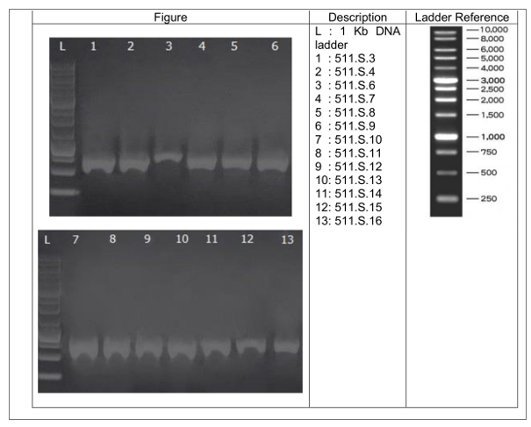
Figure 1. Agarose gel electrophoresis of PCR-amplified fragments from the 13 analyzed samples. L indicates the 1-kb DNA ladder. Lanes 1-13 correspond to samples 511.S.3, 511.S.4, 511.S.6, 511.S.7, 511.S.8, 511.S.9, 511.S.10, 511.S.11, 511.S.12, 511.S.13, 511.S.14, 511.S.15, and 511.S.16.
Sequencing performance
Bidirectional Sanger sequencing was successful for all 13 PCR products. The laboratory report classified both forward and reverse sequencing results as normal and successful for each sample. The paired reads were assembled into consensus sequences that were used for BLASTn, multiple sequence alignment, and phylogenetic analysis.
BLASTn-based sequence similarity analysis
BLASTn analysis showed high similarity between every study consensus sequence and multiple human reference records. Importantly, the top-hit sets for the same single amplicon recurrently contained both BGN-annotated and G6PD-annotated records. Across samples, query coverage ranged from 99% to 100%, percentage identity ranged from 99.64% to 100%, and E-values were 0. Recurrent BGN-annotated records included DQ173610.1, DQ173614.1, DQ173592.1, DQ173596.1, and DQ173608.1; recurrent G6PD-annotated records included AY158101.1, ON262108.1, NG_009015.2, AY158129.1, and AY158134.1 (Table 3). These results demonstrate strong sequence similarity to both annotation groups but do not represent two independent gene-specific amplification results.

Table 3. Summary of BLASTn similarity metrics and representative BGN- and G6PD-annotated top-hit records
Sample code | Max score | Query coverage | Identity (%) | E-value | Representative BGN-annotated accession | Representative G6PD-annotated accession
511.S.3 | 1027 | 99% | 99.64 | 0 | DQ173610.1 | AY158101.1
511.S.4 | 1033 | 100% | 100 | 0 | DQ173610.1 | AY158101.1
511.S.6 | 1037 | 100% | 100 | 0 | DQ173610.1 | AY158101.1
511.S.7 | 1031 | 100% | 100 | 0 | DQ173610.1 | AY158101.1
511.S.8 | 1037 | 100% | 100 | 0 | DQ173610.1 | AY158101.1
511.S.9 | 1011 | 99-100% | 100 | 0 | DQ173610.1 | AY158101.1
511.S.10 | 1011 | 100% | 100 | 0 | DQ173610.1 | AY158101.1
511.S.11 | 1037 | 100% | 99.82 | 0 | DQ173610.1 | AY158101.1
511.S.12 | 1055 | 100% | 99.83 | 0 | DQ173610.1 | AY158101.1
511.S.13 | 1044 | 99% | 99.65 | 0 | DQ173610.1 | AY158101.1
511.S.14 | 1044 | 99% | 99.65 | 0 | DQ173610.1 | AY158101.1
511.S.15 | 1031 | 100% | 100 | 0 | DQ173610.1 | AY158101.1
511.S.16 | 1221 | 100% | 100 | 0 | DQ173610.1 | AY158101.1
Note: The BGN- and G6PD-labeled accessions shown in this table were recovered from the same consensus amplicon for each sample and therefore represent database top-hit annotations rather than results of separate gene-specific PCR assays. Other recurrent BGN-annotated records included DQ173614.1, DQ173592.1, DQ173596.1, and DQ173608.1; other recurrent G6PD-annotated records included ON262108.1, NG_009015.2, AY158129.1, and AY158134.1.

Multiple sequence alignment
Multiple sequence alignment demonstrated high conservation among the 13 study consensus sequences, with limited nucleotide differences visible at several positions (Figure 2). This pattern is consistent with sequencing of the same targeted amplicon across all samples and supports the use of the consensus sequences for comparative analysis.
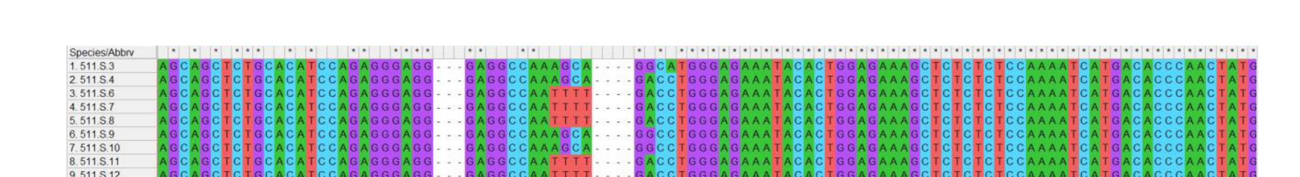
Figure 2. Multiple sequence alignment of consensus sequences from the 13 analyzed samples.
Phylogenetic reconstruction
The individual sample-reference phylogenetic trees provided in the laboratory report placed each study sequence relative to selected BGN- and G6PD-annotated reference records. In most individual trees, the study sequence was positioned within or immediately adjacent to BGN-annotated branches, whereas the selected G6PD-annotated references frequently formed a separate cluster with high bootstrap support. Placement was not equally decisive for every sample, and support around some study-sequence branches was modest; the trees were therefore interpreted as contextual evidence rather than definitive locus assignment. The all-sample tree showed internal clustering among the 13 consensus sequences, with bootstrap values ranging from 43 to 98. Notable paired clusters included 511.S.13/511.S.14 (bootstrap 92) and 511.S.6/511.S.12 (bootstrap 78) (Figure 3).
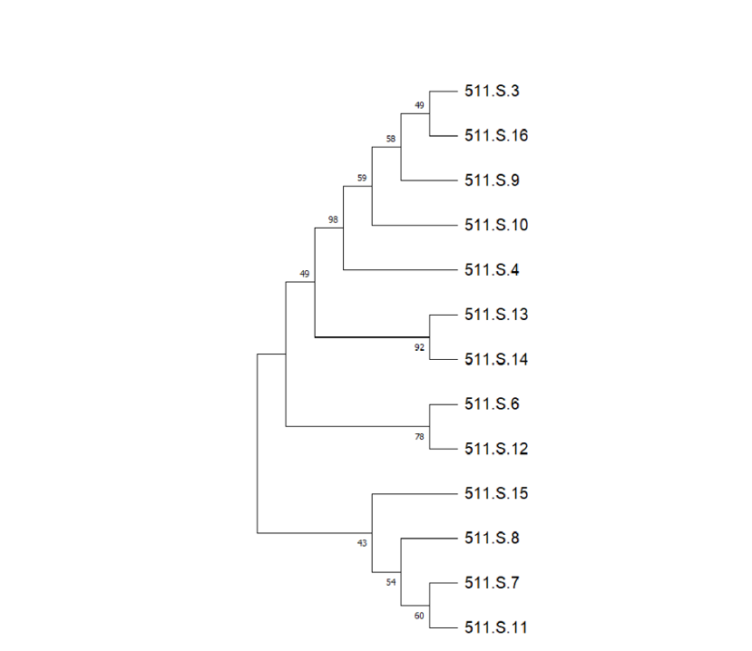
Figure 3. Neighbor-Joining phylogenetic tree summarizing the relationships among all analyzed sample consensus sequences. Bootstrap values are shown at the nodes.
Discussion
This study provides a sequence-based characterization of one approximately 700-bp human genomic amplicon across 13 anonymized blood samples. The wet-laboratory component was technically consistent: each sample produced a single visible PCR band at the expected size, both sequencing directions were reported as successful, and the resulting consensus sequences showed high similarity to human database records. The central interpretive finding, however, is that the same consensus amplicon repeatedly retrieved top BLASTn hits carrying both BGN and G6PD annotation labels.
The PCR and sequencing results support the reproducibility of the laboratory workflow but do not, by themselves, establish locus identity. A single band indicates that one dominant product of the expected approximate size was amplified under the tested conditions, while bidirectional Sanger sequencing strengthens confidence in the consensus sequence generated from that product (1,2). These observations justify downstream sequence comparison but should be distinguished from gene-specific confirmation.
The BLASTn findings require particular care. Query coverage of 99-100%, identity of 99.64-100%, and E-values of 0 demonstrate strong similarity between the study sequences and the retrieved database records. Nevertheless, BLAST is fundamentally a similarity-search approach, and the descriptive annotation attached to a high-scoring record should not automatically be treated as locus proof. Public sequence databases are indispensable resources, but annotation inconsistencies and record-level errors can occur and may propagate across related records (17,18,26). In the present dataset, the fact that one consensus amplicon yielded highly ranked records labeled as both BGN and G6PD is therefore best reported as an annotation ambiguity that requires locus-specific verification rather than as confirmation of two separate genes.
The phylogenetic analyses add useful context to this interpretation. In most individual sample-reference trees in the laboratory report, study sequences were located within or close to BGN-annotated reference branches, while G6PD-annotated references often formed a separate supported cluster. At the same time, placement of some study sequences was less decisive and bootstrap support around sample branches was not uniformly high. Phylogenetic topology is consequently supportive of relative sequence relatedness but is not sufficient to resolve the gene assignment by itself, particularly when the underlying reference records carry discordant annotation labels (21-25).
The multiple sequence alignment showed that the 13 consensus sequences were highly conserved, with only limited nucleotide differences. This finding is compatible with amplification of the same genomic region across the study set and provides a basis for future variant-level analysis. However, no formal variant calling, pathogenicity classification, functional assay, or genotype-phenotype analysis was performed, so the observed sequence differences should not be assigned clinical significance.
A strength of the study is the use of complementary experimental and computational steps: DNA extraction, PCR, gel electrophoresis, bidirectional sequencing, consensus assembly, BLASTn, multiple sequence alignment, and phylogenetic reconstruction. Reframing the result around a single experimentally generated amplicon avoids an unsupported two-gene claim while preserving the informative observation that different annotation groups appeared among the highest-scoring reference matches. This is relevant to molecular diagnostic workflows because sequence identity, database annotation, and locus confirmation are related but distinct analytical questions.
The study has several limitations. The sample size was limited to 13, only a targeted amplicon was analyzed, and consensus sequences have not yet been publicly deposited. The laboratory report also does not provide a reference-genome coordinate mapping of the primers or an independent gene-specific assay that would resolve the BGN/G6PD annotation discrepancy. Future work should map the primer pair and consensus sequences to a current human reference genome, perform target-specific in silico specificity assessment, use independent locus-specific primers if confirmation of either gene is intended, deposit the consensus sequences and chromatograms in an appropriate repository, and conduct variant-level analysis where biologically or clinically justified. These steps would allow definitive locus assignment without extending the present data beyond what the sequencing report supports.
Conclusion
A single approximately 700-bp human genomic amplicon was reproducibly generated and successfully sequenced in all 13 analyzed samples. The resulting consensus sequences showed 99-100% BLASTn query coverage, 99.64-100% identity, and E-values of 0 against recurrent human reference records annotated as BGN and G6PD. Multiple sequence alignment demonstrated high conservation, and phylogenetic analyses provided additional context for the relationships among study and reference sequences. Because the same primer pair and single amplicon generated matches to both annotation groups, the data do not support claiming independent molecular confirmation of BGN and G6PD. The defensible interpretation is high sequence similarity to BGN- and G6PD-annotated reference records, with definitive locus assignment requiring reference-genome mapping or independent target-specific validation.
Declaration of Generative AI and AI-Assisted Technologies in the Writing Process
AI-assisted language tools were used only to improve grammar, clarity, and formatting. They were not used to generate scientific content, perform data analysis, create or manipulate scientific figures, or draw conclusions. The authors reviewed all edited text and take full responsibility for the scientific accuracy, interpretation, originality, and integrity of the manuscript.
Ethics Approval
The study protocol was approved by an institutional ethics committee (ethical code: KET-933/UN2.F1/ETIK/PPM.00.02/2026; protocol number: 26-04-0499; approval date: July 06, 2026). The study was conducted in accordance with the Declaration of Helsinki and applicable national ethical requirements.
Consent to Participate
All participants, or their legal guardians where applicable, voluntarily agreed to participate in this research. Written informed consent was obtained before sample collection.
Acknowledgement
The authors thank the laboratory members and technical staff who supported DNA extraction, PCR amplification, Sanger sequencing, sequence assembly, and bioinformatics analysis.
Funding
This research received no specific grant from any funding agency in the public, commercial, or not-for-profit sectors.
Conflict of Interest
The authors declare that they have no conflicts of interest.
Data Availability
The laboratory report documents generation of raw chromatogram files (.ab1), DNA sequence files (.seq), assembled consensus sequences in FASTA format, alignment files (.mas), MEGA phylogenetic tree files (.mtsx), and phylogenetic tree images (.png). These files are available from the corresponding author upon reasonable request. Public accession numbers will be added if the consensus sequences are deposited during peer review or revision.
Supplementary Information
Individual sample-reference phylogenetic trees and the available sequencing, alignment, and phylogenetic analysis files may be provided as supplementary material or to the editor and reviewers upon request.
References
1. Crossley BM, Bai J, Glaser A, Maes R, Porter E, Killian ML, et al. Guidelines for Sanger sequencing and molecular assay monitoring. J Vet Diagn Invest. 2020;32(6):767-775. https://doi.org/10.1177/1040638720905833.
2. Mu W, Lu HM, Chen J, Li S, Elliott AM. Sanger validation of high-throughput sequencing in genetic diagnosis: still the best practice? Front Genet. 2020;11:592588. https://doi.org/10.3389/fgene.2020.592588.
3. Koboldt DC. Best practices for variant calling in clinical sequencing. Genome Med. 2020;12:91. https://doi.org/10.1186/s13073-020-00791-w.
4. Logsdon GA, Vollger MR, Eichler EE. Long-read human genome sequencing and its applications. Nat Rev Genet. 2020;21(10):597-614. https://doi.org/10.1038/s41576-020-0236-x.
5. Mantere T, Kersten S, Hoischen A. Long-read sequencing emerging in medical genetics. Front Genet. 2019;10:426. https://doi.org/10.3389/fgene.2019.00426.
6. Wenger AM, Peluso P, Rowell WJ, Chang PC, Hall RJ, Concepcion GT, et al. Accurate circular consensus long-read sequencing improves variant detection and assembly of a human genome. Nat Biotechnol. 2019;37(10):1155-1162. https://doi.org/10.1038/s41587-019-0217-9.
7. Austin-Tse CA, Jobanputra V, Perry DL, Bick D, Taft RJ, Venner E, et al. Best practices for the interpretation and reporting of clinical whole genome sequencing. NPJ Genom Med. 2022;7(1):27. https://doi.org/10.1038/s41525-022-00295-z.
8. Appunni S, Rubens M, Ramamoorthy V, Anand V, Khandelwal M, Sharma A. Biglycan: an emerging small leucine-rich proteoglycan marker and its clinicopathological significance. Mol Cell Biochem. 2021;476(11):3935-3950. https://doi.org/10.1007/s11010-021-04216-z.
9. Roedig H, Nastase MV, Wygrecka M, Schaefer L. Breaking down chronic inflammatory diseases: the role of biglycan in promoting a switch between inflammation and autophagy. FEBS J. 2019;286(15):2965-2979. https://doi.org/10.1111/febs.14791.
10. Kram V, Shainer R, Jani P, Meester JAN, Loeys B, Young MF. Biglycan in the skeleton. J Histochem Cytochem. 2020;68(10):747-762. https://doi.org/10.1369/0022155420937371.
11. Roedig H, Nastase MV, Wygrecka M, Schaefer L. Biglycan is a new high-affinity ligand for CD14 in macrophages. Matrix Biol. 2019;77:4-22. https://doi.org/10.1016/j.matbio.2018.05.006.
12. Luzzatto L, Ally M, Notaro R. Glucose-6-phosphate dehydrogenase deficiency. Blood. 2020;136(11):1225-1240. https://doi.org/10.1182/blood.2019000944.
13. Tantular IS, Kawamoto F, Matsuoka H, Sumitro SB, Dwi S, et al. Distribution of G6PD deficiency genotypes among Southeast Asian populations. Trop Med Health. 2021;49(1):97. https://doi.org/10.1186/s41182-021-00387-z.
14. Chu CS, Bancone G, Nosten F, White NJ, Luzzatto L. Primaquine-induced haemolysis in females heterozygous for G6PD deficiency. Malar J. 2020;19(1):256. https://doi.org/10.1186/s12936-020-03303-y.
15. Bancone G, Chu CS. G6PD variants and haemolytic sensitivity to primaquine and other drugs. Front Pharmacol. 2021;12:638885. https://doi.org/10.3389/fphar.2021.638885.
16. Lee HY, Ithnin A, Azma RZ, Othman A, Salvador A, Cheah FC. Glucose-6-phosphate dehydrogenase deficiency and neonatal hyperbilirubinemia: insights on pathophysiology, diagnosis, and gene variants in disease heterogeneity. Front Pediatr. 2022;10:875877. https://doi.org/10.3389/fped.2022.875877.
17. The NCBI Resource Coordinators. Database resources of the National Center for Biotechnology Information. Nucleic Acids Res. 2024;52(D1):D33-D43. https://doi.org/10.1093/nar/gkad1044.
18. Goudey B, Geard N, Verspoor K, Zobel J. Propagation, detection and correction of errors using the sequence database network. Brief Bioinform. 2022;23(6):bbac416. https://doi.org/10.1093/bib/bbac416.
19. Edgar RC. Muscle5: high-accuracy alignment ensembles enable unbiased assessments of sequence homology and phylogeny. Nat Commun. 2022;13(1):6968. https://doi.org/10.1038/s41467-022-34630-w.
20. Katoh K, Rozewicki J, Yamada KD. MAFFT online service: multiple sequence alignment, interactive sequence choice and visualization. Brief Bioinform. 2019;20(4):1160-1166. https://doi.org/10.1093/bib/bbx108.
21. Tamura K, Stecher G, Kumar S. MEGA11: Molecular Evolutionary Genetics Analysis Version 11. Mol Biol Evol. 2021;38(7):3022-3027. https://doi.org/10.1093/molbev/msab120.
22. Kumar S, Stecher G, Suleski M, Sanderford M, Sharma S, Tamura K. MEGA12: Molecular Evolutionary Genetic Analysis Version 12 for Adaptive and Green Computing. Mol Biol Evol. 2024;41(12):msae263. https://doi.org/10.1093/molbev/msae263.
23. Minh BQ, Schmidt HA, Chernomor O, Schrempf D, Woodhams MD, von Haeseler A, et al. IQ-TREE 2: new models and efficient methods for phylogenetic inference in the genomic era. Mol Biol Evol. 2020;37(5):1530-1534. https://doi.org/10.1093/molbev/msaa015.
24. Kozlov AM, Darriba D, Flouri T, Morel B, Stamatakis A. RAxML-NG: a fast, scalable and user-friendly tool for maximum likelihood phylogenetic inference. Bioinformatics. 2019;35(21):4453-4455. https://doi.org/10.1093/bioinformatics/btz305.
25. Letunic I, Bork P. Interactive Tree Of Life (iTOL) v5: an online tool for phylogenetic tree display and annotation. Nucleic Acids Res. 2021;49(W1):W293-W296. https://doi.org/10.1093/nar/gkab301.
26. Sayers EW, Cavanaugh M, Clark K, Ostell J, Pruitt KD, Karsch-Mizrachi I. GenBank. Nucleic Acids Res. 2020;48(D1):D84-D86. https://doi.org/10.1093/nar/gkz956.

